MIS 5732 - Test 2 (80 Points)
Creating Dashboards for Retail Stores Managers

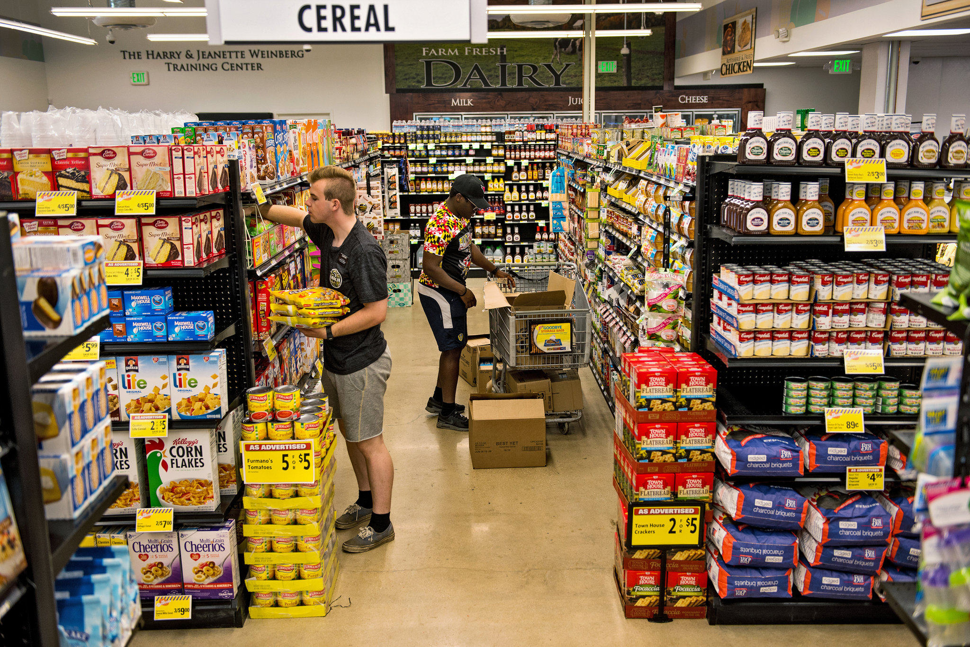

Overview:
The Retail Stores dataset includes data collected from registers/scanner receipts of customers buying groceries and other items from the store-chain Dominick's Finer Foods in the Chicago area during the period 2011-2019. This dataset is a small randomly chosen subset of the actual dataset and contains 4,000 observations covering 21 variables. The Demographics dataset (11 variables) includes information on the socio-demographic characteristics of the neighborhoods where these stores are located.
The data and questions are very realistic to a grocery business.
This grocery chain is interested in comparing current purchase patterns with those of earlier years.

Goals:
You have been hired to develop a dashboard for the company’s managers to help them make the appropriate decisions about the store chain - the products sold and characteristics of buyer, to identify patterns in purchasing behaviors.
Please note that there are five sections in the assignment: A, B, C, D, and E. Make sure you complete all of them.

Section A – Merging the two datasets (5 points)
Merge the two datasets using the variable [Shop ID] in the Retail Stores dataset and [Supermarket ID] in the Demographics dataset.
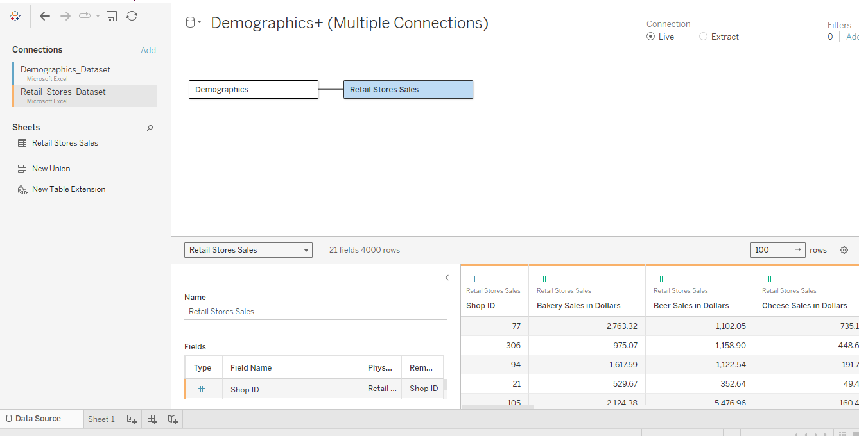

Section B - Development of the First Dashboard (15 points)
Create a first dashboard with the two following sheets:
Sheet 1: Create a sheet with a parameter that allows the user to select/choose from the following measures to visually observe sales trends over time (use [Date of sale] as the time variable). Name the parameter “Food Sales”.
Dairy Sales in Dollars
Meat Sales in Dollars
Salad Bar Sales in Dollars

-Make sure the date dimension [Date of Sale] is in the format May 2015.
-Also, use the appropriate aggregate function for the sales amount.
-Also, add a Zip Code filter and show it in the “Multiple Values” drop-down format.
This sheet should allow the user to choose and see trends in sales of the three products over time, based on zip code.
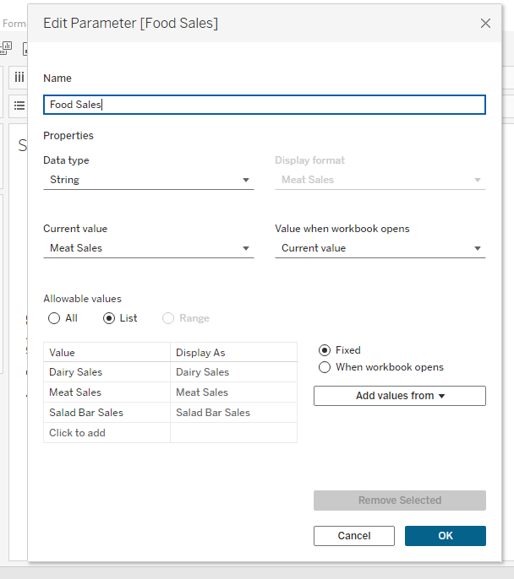
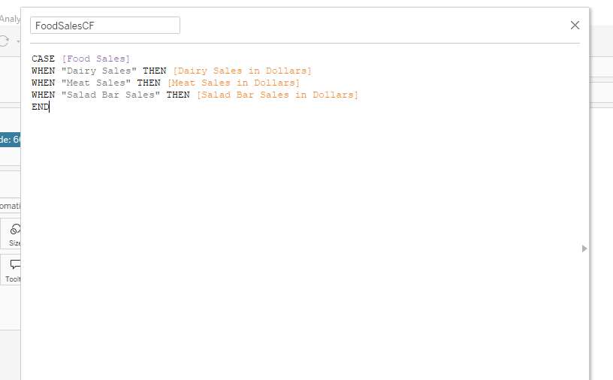
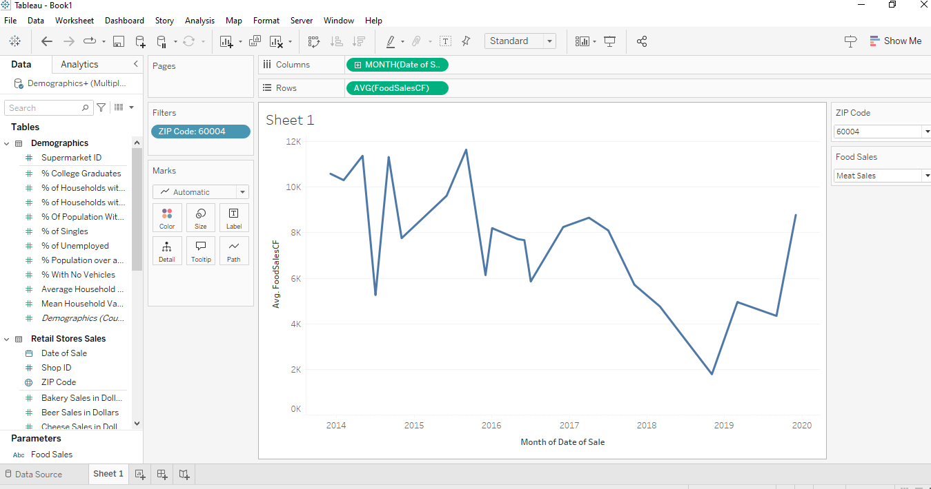

Sheet 2: Using the Zip Code dimension and the parameter you have created in Sheet 1, create a geographic area map showing the sales dollar amounts for the products included in the parameters. Set a time filter for this sheet using the year of the [Date of Sales] dimension.
This sheet should show the sales amounts of various selected products and selected year in all the zip codes, in a geographic representation.
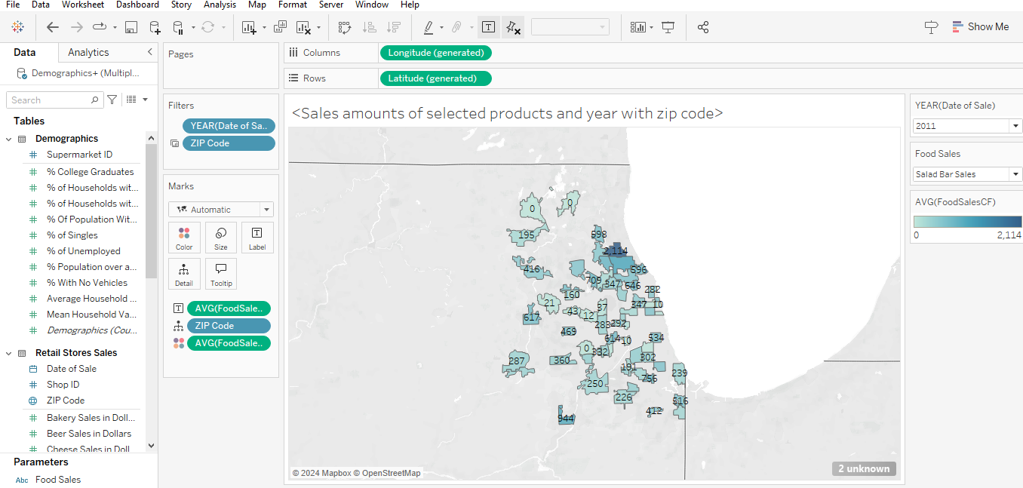
Specifics of the dashboard – Create titles for the panels (sheets). Please note that the sheet 2 panel should be the filter for the dashboard so that when a user clicks on a zip code, and chooses any specific product in the parameter, it will show the sales of this product over time.
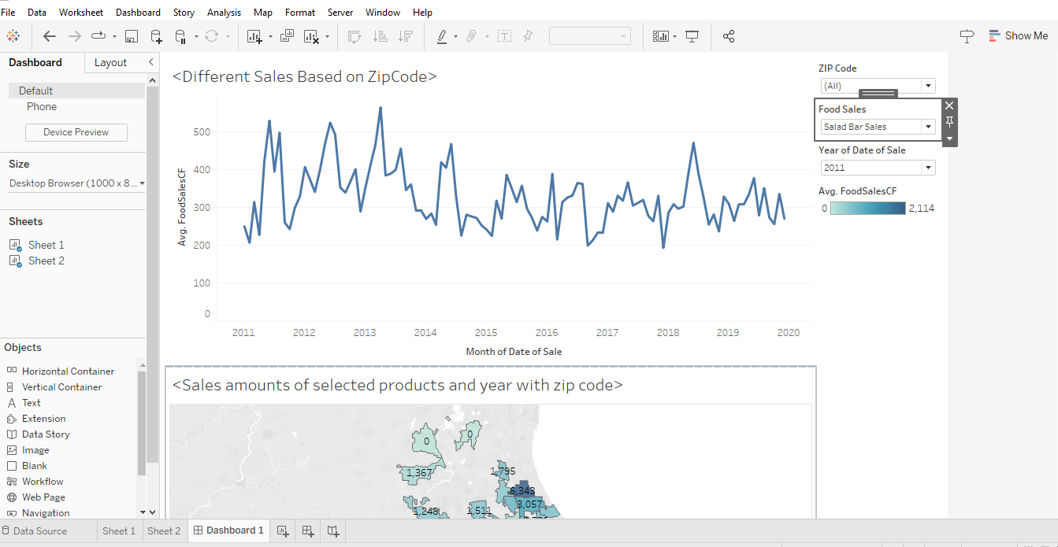

Section C- Development of the Second Dashboard (20 points)
Your objective is to give managers the ability to understand the relationships between demographic characteristics and the sales of specific products over all zip codes. Please note that for this exercise, you should use the appropriate type of aggregation for demographics.
Sheet 3: Create a visualization that can help identify the relationship between demographic characteristics and sales of specific products.
Create two parameters:
-The first one is for the following demographics (name the parameter “Demographic Variables”)
- % College Graduates
- % Population over age 60
- % of Households with Value over $150,000

-The second parameter is for the following product sales (name the parameter “Product Sales”):
- Cheese Sales in Dollars
- Fish Sales in Dollars
- Floral Sales in Dollars
- Wine Sales in Dollars

Note: Avoid typos and use the same and appropriate aggregate function for both parameters when creating the visualization for the relationship.
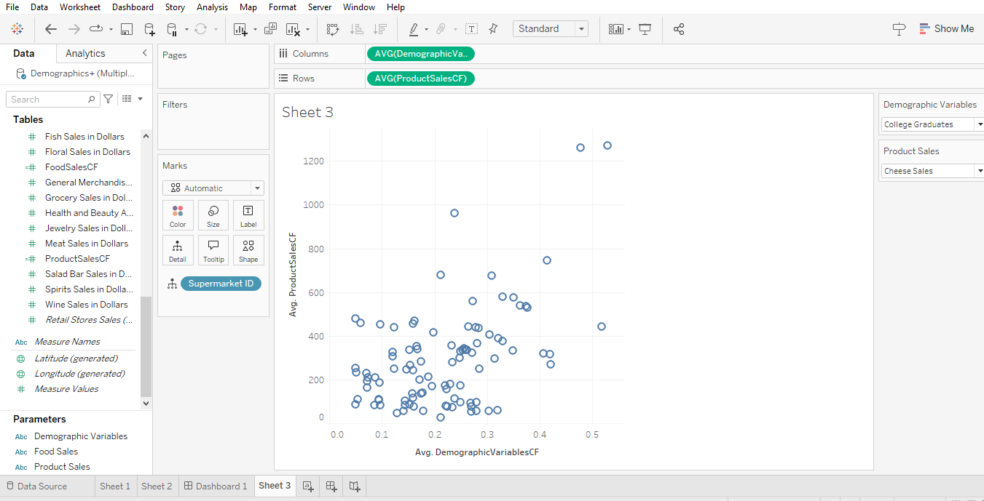

Sheet 4: (Visualize demographic characteristics by zip code)

Using the Zip code dimension and the “Demographic Variables” parameter you have created above, create a geographic area map (choropleth) of sociodemographic characteristics. Use appropriate aggregate function for the “Demographic Variables” parameter.
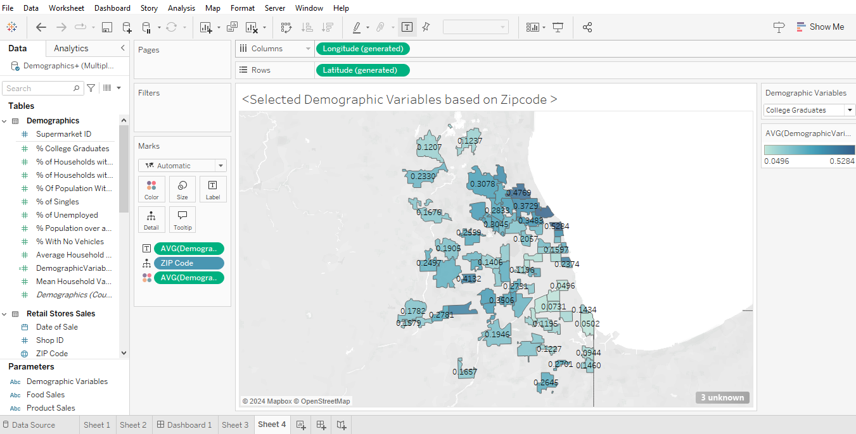

The second dashboard should include Sheets 3 and 4 as panels. The “Demographic Variables” parameter should apply to both sheets (panels) while the “Product Sales” parameter is linked to Sheet 3 (panel) only.

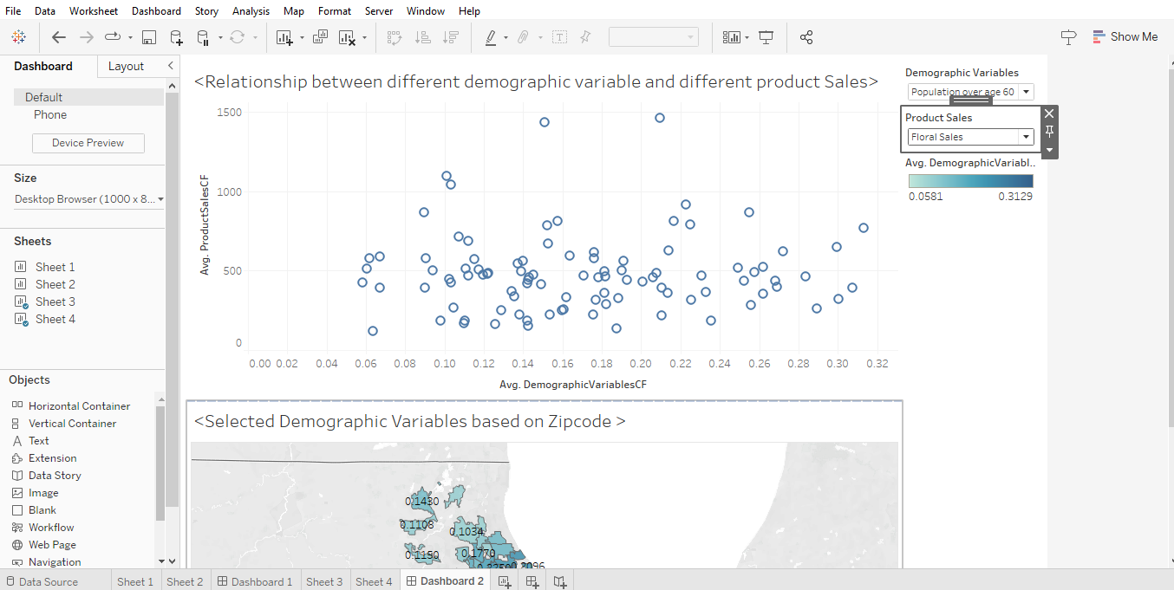

Section D-Homepage Dashboard (10 points)
Finally, create a homepage dashboard with good formatting that allows the user to navigate to these two dashboards and go back to the homepage. Be sure to give the right captions and titles and format the homepage and dashboard to have a good visual look.

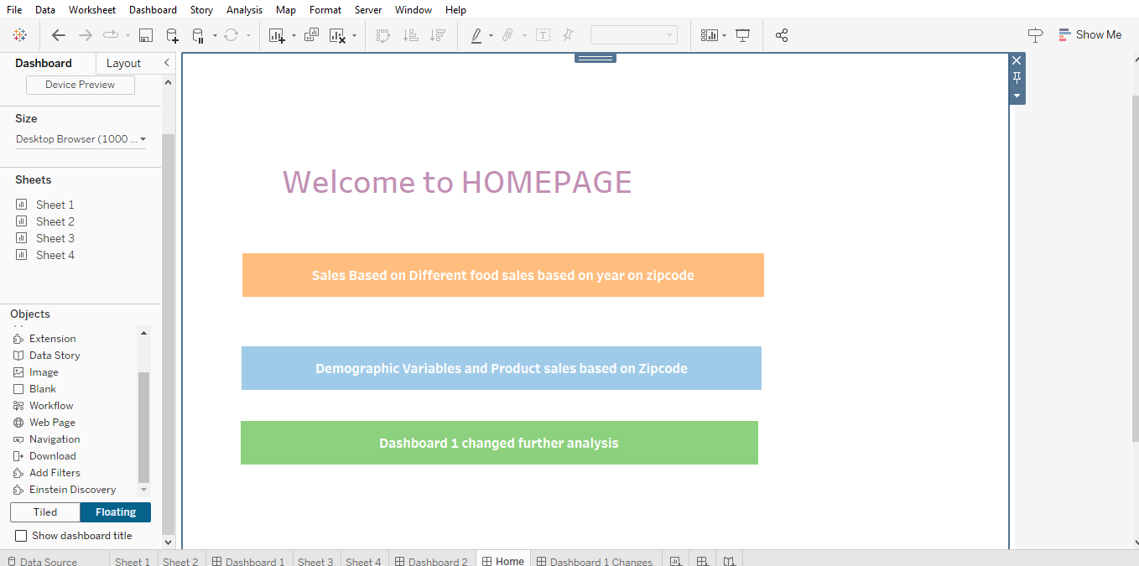

Section E- Dashboard Interpretation (30 points)
Question 1 (use Dashboard 1) (5 points)
- What are the two products with the highest sales in dollar amount overall (i.e. all area codes combined)?
Meat Sales & Dairy Sales are the highest sales in dollar amount overall.
- What was the sales amount for [Salad Bar Sales in Dollars] in April 2019 for the Zip code 60090?
It was $686.
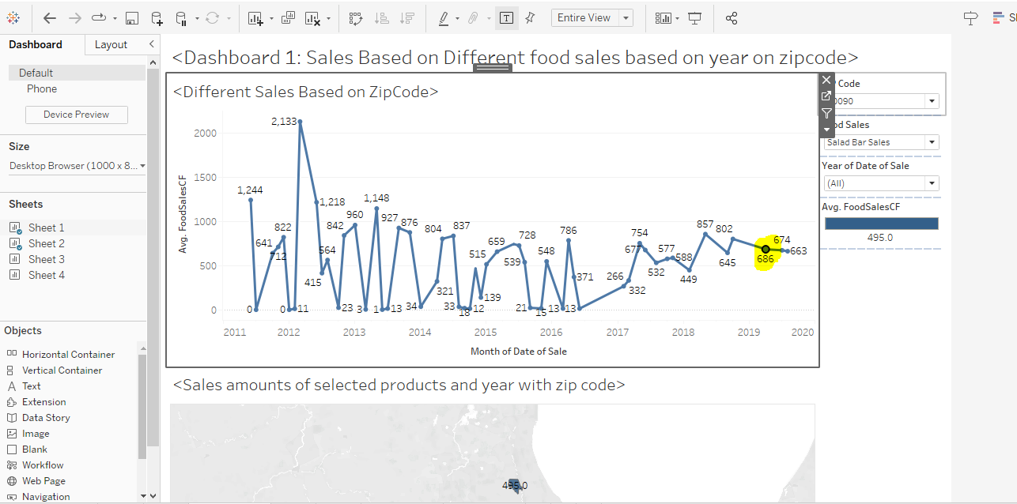
Question 2 (use Dashboard 1) (5 points)
a) In order to avoid any product shortage during high demand periods, the manager wants to know which month of the year has the highest sales for the products in your parameter. What small change would you make to your original dashboard to help him answer this specific question?
I think the manager can set the [Date of Sale] month and set it as a filter for the Top 1. Color coding also helps. This way, it only shows the one with highest average sales of product.
The manager could change “Year” into “Month”.
And also change the Month as a filter for both sheets.

For Salad Bar Sales
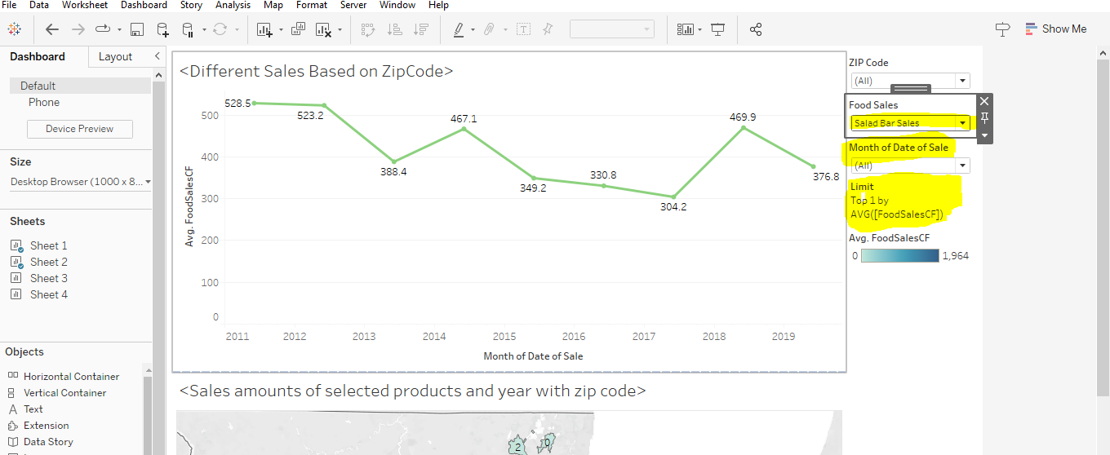
For meat sales
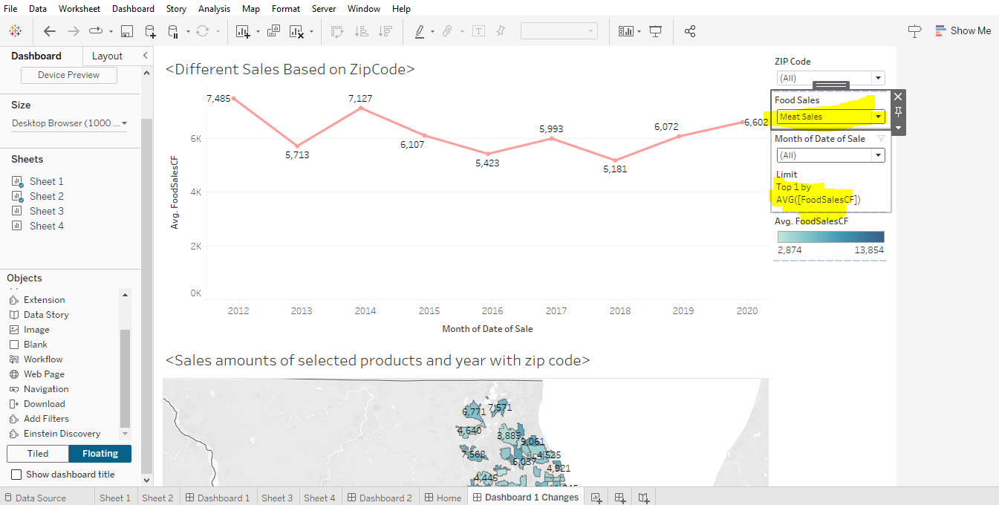

- Make the change you have suggested in a). For each of the products in your parameter (salad bar, dairy, meat), which months do we observe sales peaks overall (i.e., in all the area codes and for all years)?
- Dairy: December
- Meat: December
- Salad bar: June
Question 3 (use Dashboard 2) (5 points)

- Is there any significant relationship between Percentage of College Graduates and Floral Sales in Dollars? Answer by Yes/No and then justify your answer.
The R value is 0.205952.
The p squared value is < 0.0001.
Yes & no, there could be some corelation as the R value is 20% which is not a lot, but personally I would think it is. I think it depends on the judgement some people have preference of more than 60% or something. I think 20% linear line looks like a good relationship. And additionally, the P value which is lesser than 0.05, shows it is statistically significant.
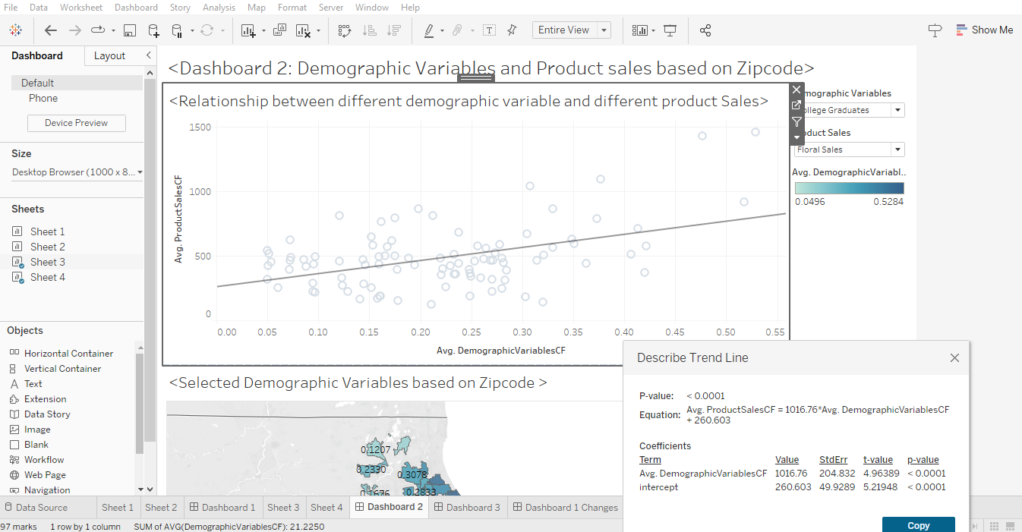
- Your coworker says that highly educated individuals usually buy fish instead of meat, because they consider fish healthier. Hence, he says, “zip codes with high percentages of College Graduates should have higher sales of fish”.

Does the data support his claim? Answer by Yes/No and then fully justify your answer.
The relationship between the only College graduate & Product Sales excluding the zipcode does NOT have a strong R value. R value is 0.01 which is extremely weak coorealtion and additionally P value is not lesser than 0.05 which also shows it is statistically insignificant.
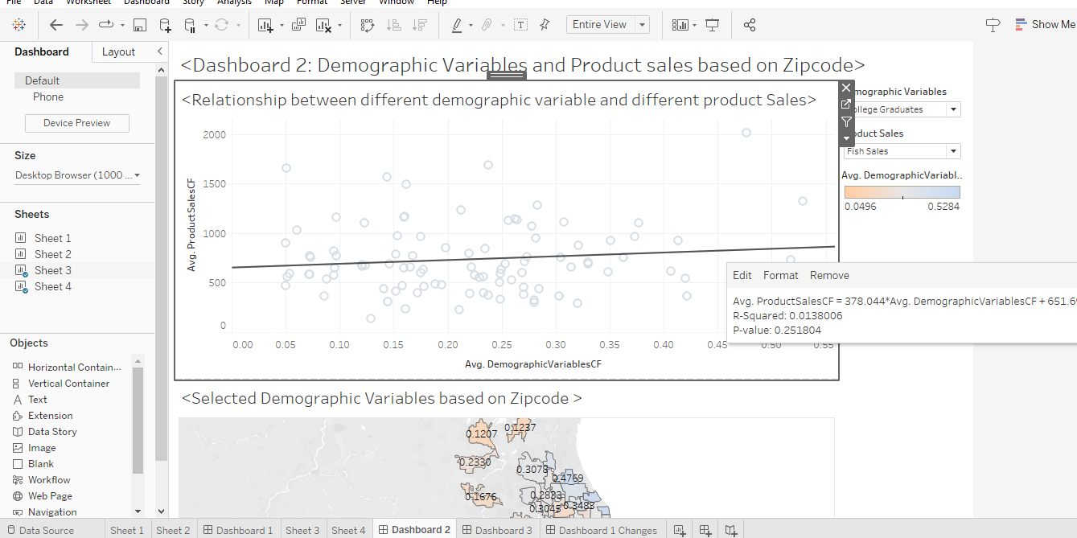
Yes, because at the same time, the highest colege gradute live at zip code 60201. And the correaltion between the normal all zip code with college grad with fish sale has the average of 378. However, the highest college graduate has the zip code of 60201, it with average of 1319, which is way high above average (378). Therefore, there is a correlation between the zipcode with highest college graduate and fish sales, as the relationship that particular zip code is way higher than the average ones.
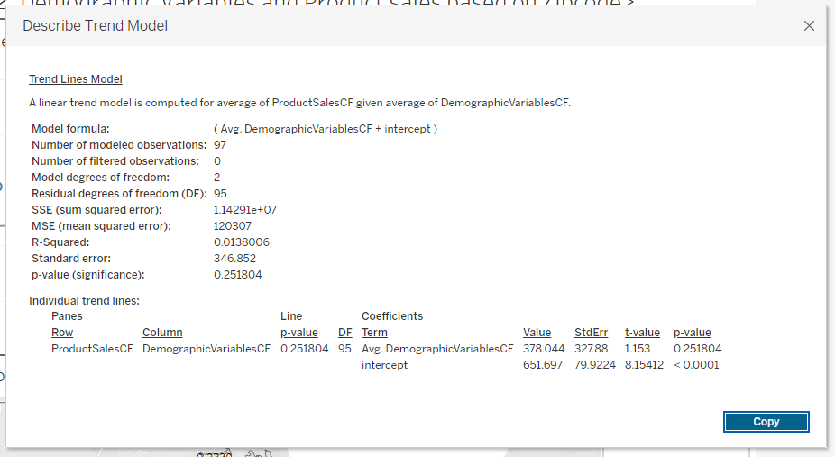
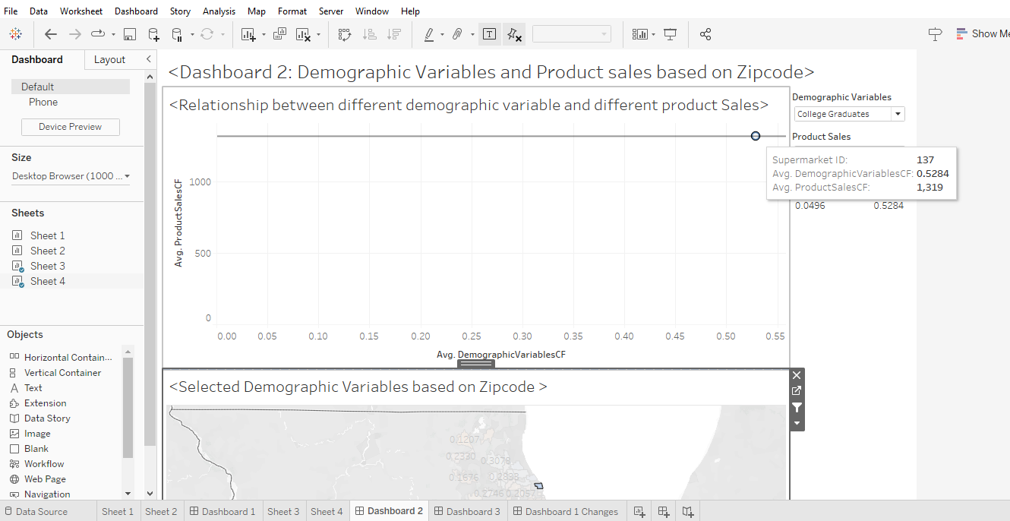
Question 4: (use Dashboard 2) (5 points)
Does the percentage of population over age 60 have an influence on wine sales?
Answer by Yes/No and then fully justify your answer.
No, there is no influence on percentage of population over age of 60 on wine sales. R square value is pretty low & p value shows there is no statistically significant either.
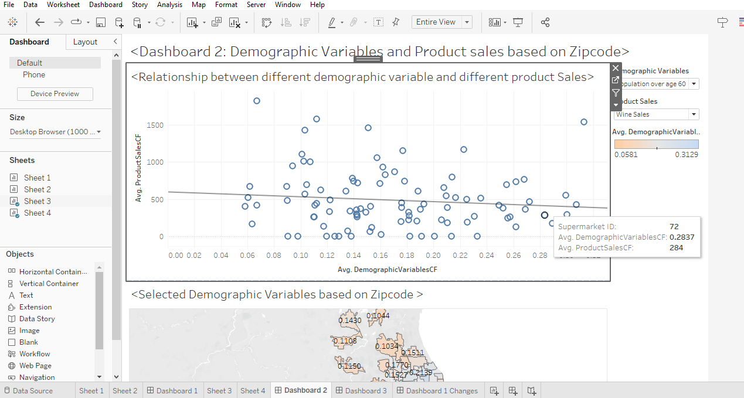
Question 5: (use Dashboard 2) (10 points)
The storage capacity of the stores in areas with a high percentage of households with values over $150,000 is limited, and the manager has to reduce the volume of items that do not sell well in these areas.
- What analysis strategy would you suggest and why?
On dashboard 2, the sheet 3 shows a coorealtion between the high percentage of households with values over $150,000 and product sales. The filter can be tried to see which one has the lowest corelation to remove to reduce the volume of that particular item that do not sell well.
The fish sales has the lowest coorealtion with high percentage of households with values over $150,000. This should be removed.

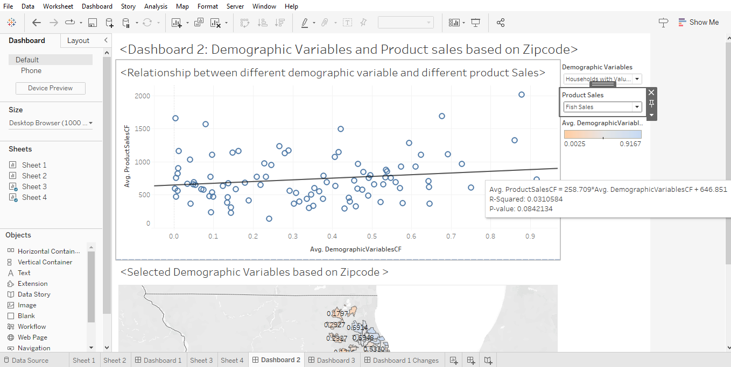
b) Which 2 products that you analyzed using the parameters are worth keeping and why?
I think you should keep the cheese and Floral as it has higher coorealtion with both P value with statistical significance and R value of better than the four products.
